
TO LET

OFFICE SPACE TO LET ON 1st, 2nd and 3rd FLOOR

42 South Mall,
Cork.

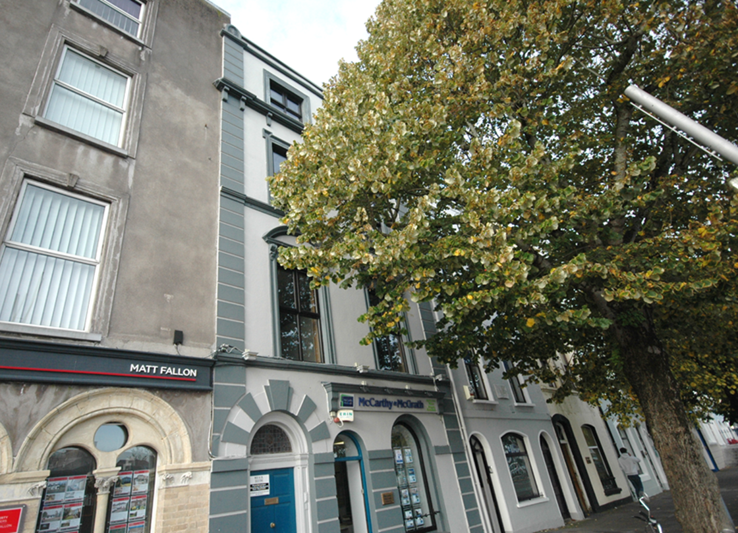

McCarthy & McGrath are delighted to present these centrally located offices to let. This property is conveniently situated on the corner of South Mall and Grand Parade and the offices are laid out in a variety of sizes over three floors.

Viewing is highly recommended & strictly by prior appointment with the sole letting agents.

Rent on application

Accommodation:

FIRST FLOOR
Reception: 3.7m x 2.7m
Office 1: 3.5m x 3.8m
Office 2: 3.2m x 4.8m

SECOND FLOOR
Office 1: 6.4m x 3.7m
Office 2: 3.5m x 3.8m

THIRD FLOOR
Office 1: 6.4m x 3.7m
Office 2: 3.5m x 3.8m

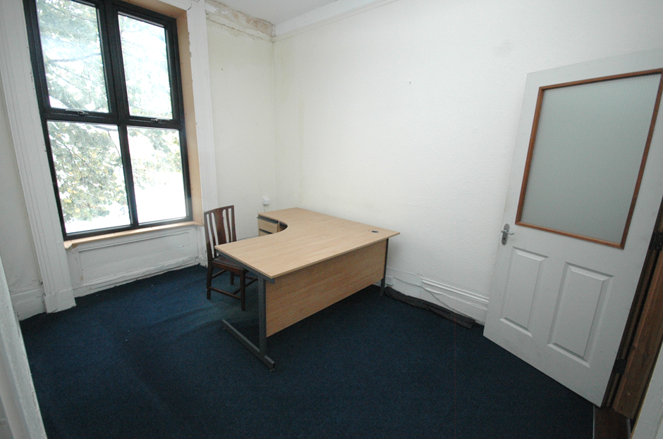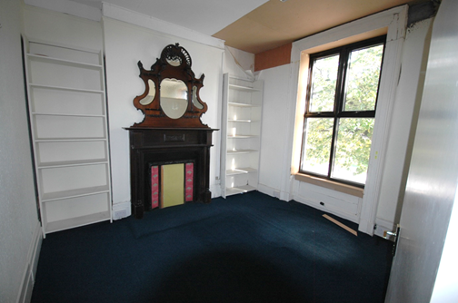

FEATURES:

- Offices to let in central location.
- Available on 1st, 2nd and 3rd floors.
- Situated on the corner of South Mall and Grand Parade.
- Contact our agent to arrange viewing.

EIRCODE : T12 WP60
BER DETAILS: Pending
SERVICES : Water, Electricity
VIEWINGS : Strictly by prior appointment with the sole letting agents.
42 South Mall, Cork t: 021 4273800
39 Main Street, Midleton, Co. Cork t: 021 4631755
e: infocork@mccarthymcgrath.com w: www.mccarthymcgrath.com
PSRA Licence No. 001757

______________________________________________________________________________________________________________________________________________________
These particulars are issued by McCarthy & McGrath on the understanding that any negotiations respecting the Property mentioned are conducted through them. Every care is taken in preparing particulars, but the firm do not hold themselves responsible for any inaccuracy in the Particulars and Terms of the Property referred to or for any expense that may be incurred in visiting same should it prove unsuitable, or to have been let, sold or withdrawn. Applicants are advised to make an appointment through us before viewing and are respectfully requested to report their opinion after inspecting. Should the above not be suitable, please let us know your exact requirements. Any reasonable offer will be submitted to the owners for consideration.

