
Bright & Spacious Three Bedroom Semi-Detached House.

33 Blossom Hill,
Broomfield Village,
Midleton,
Co. Cork.
P25 E7N5

For Sale by Private Treaty

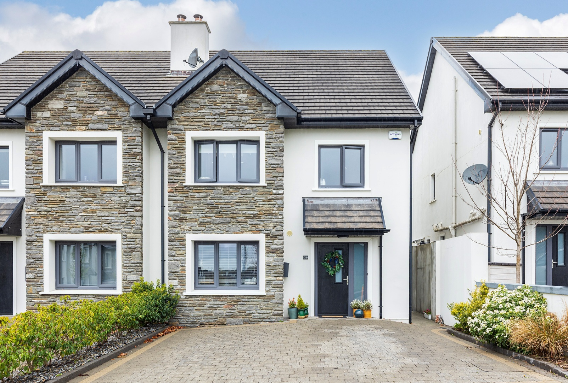

A.M.V. €415,000 

No. 33 Blossom Hill is a well presented & modern home which offers purchasers the complete balance of generous living accommodation, style, energy efficiency and location.
Superbly situated overlooking a large green area in this much sought after residential area, just a short walk from the Train Station, Midleton/Youghal Greenway & Midleton Town Centre with its vast array of schools, shops, supermarkets, bars, restaurants, cinema & the very popular Midleton Farmers Market which takes place every Saturday. The property was built in 2019 and extends to c. 118m² (1,270ft²) and is in turn-key condition having been finished and maintained to a very high standard throughout and viewing is highly recommended.

ACCOMMODATION:

Entrance Hallway: 2.01 x 2.55 white ceramic tiled floor, ‘Smart’ understairs storage.

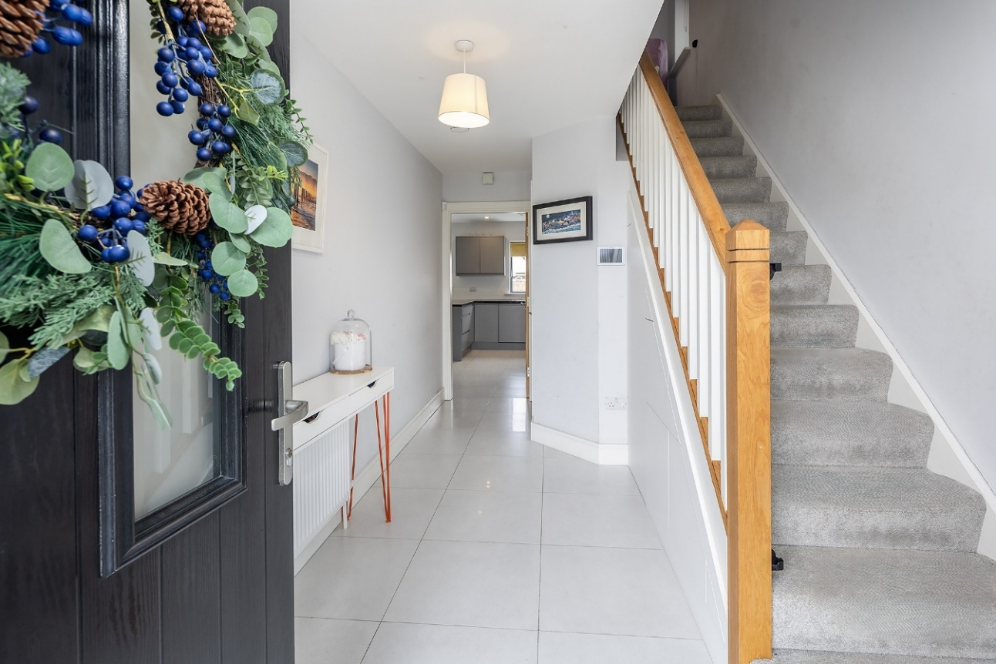

Guest w.c. : 1.61 x 1.43 tiled floor & half wall, w.c. & w.h.b.

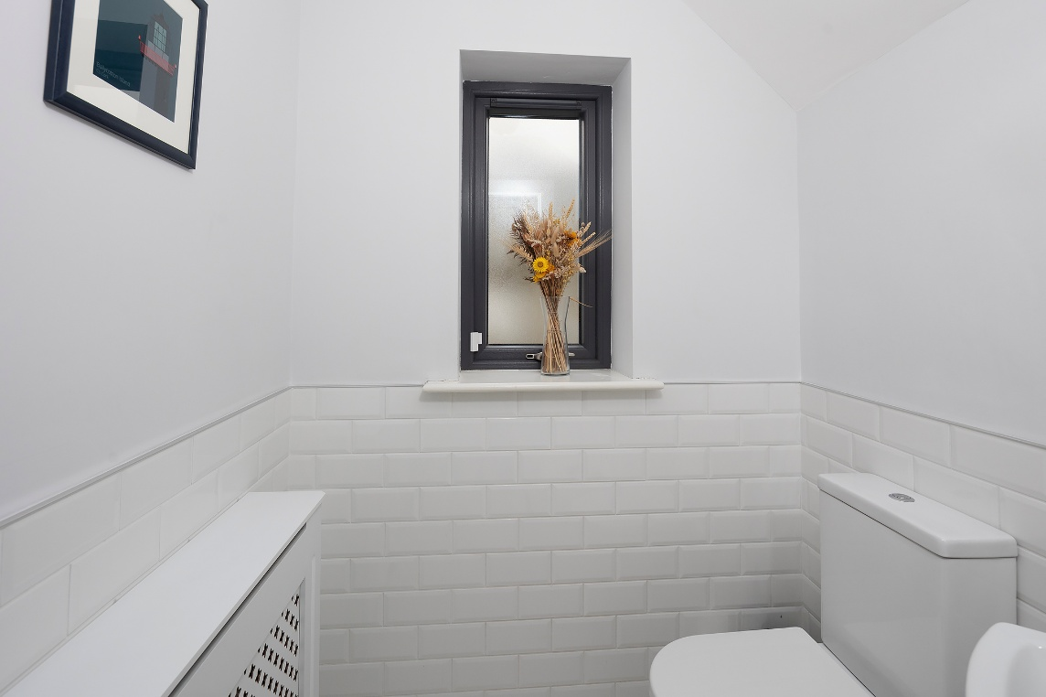
Living Room : 5.54 x 3.45 with wall to wall storage units, solid fuel stove with marble surround, bay window.

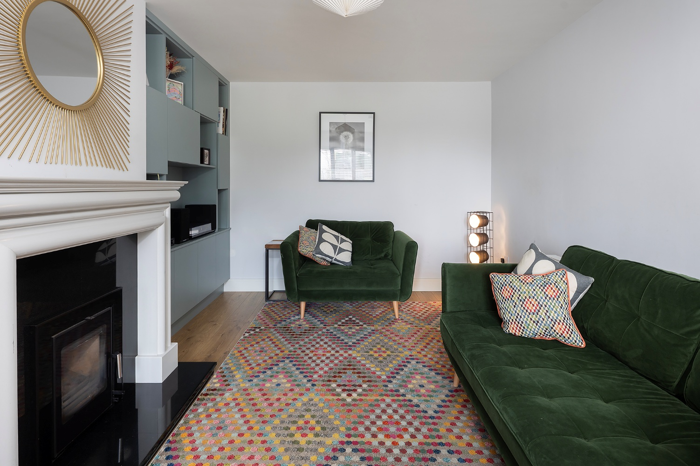

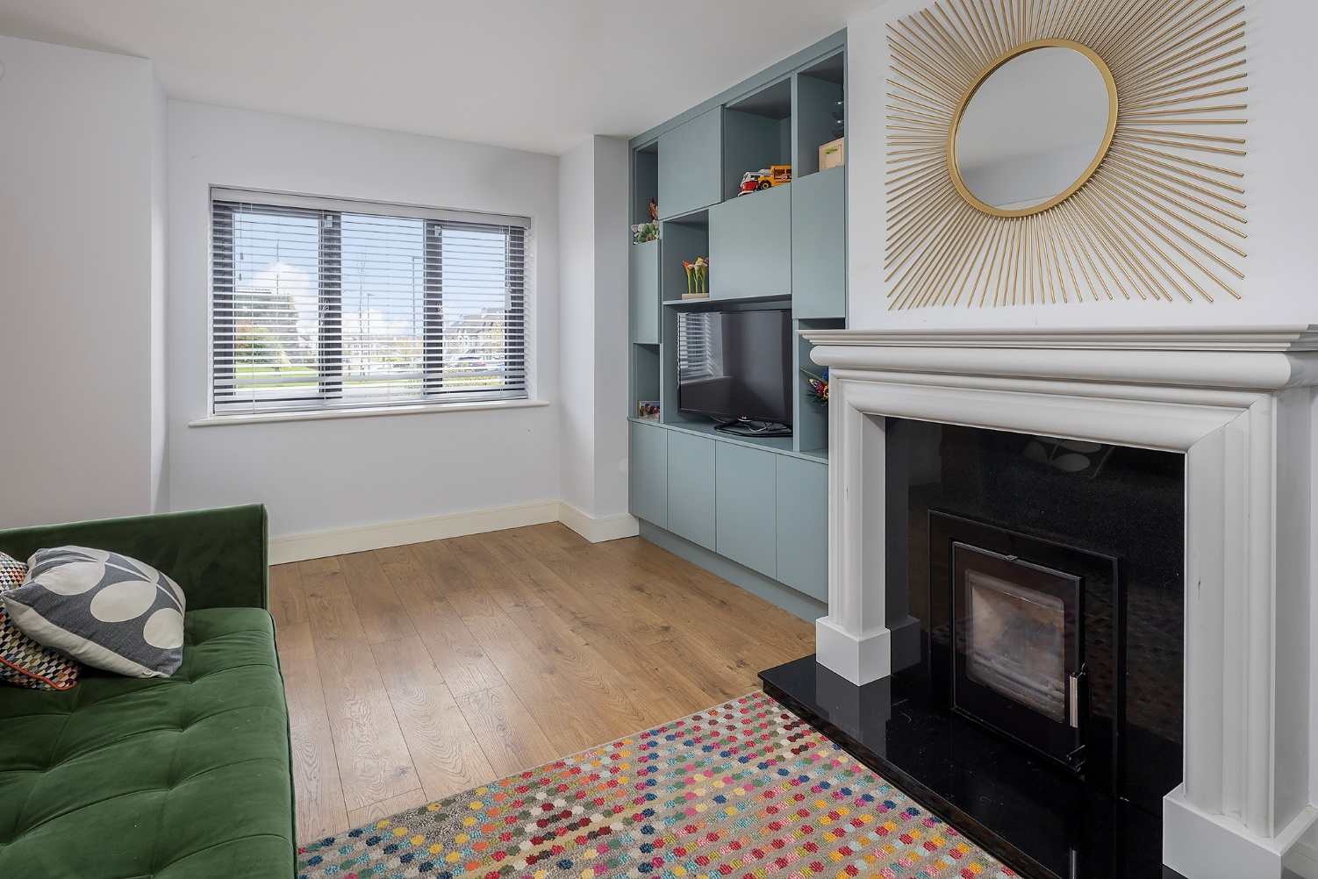

Kitchen / Dining Room : 6.17 x 4.22 built-in units & eye level presses with large larder press,
tiled splash-back, electric oven & hob, integrated fridge/freezer & dishwasher, ceramic tiled floor, recessed lighting in kitchen area.
French doors to rear patio area & garden with Westerly aspect.

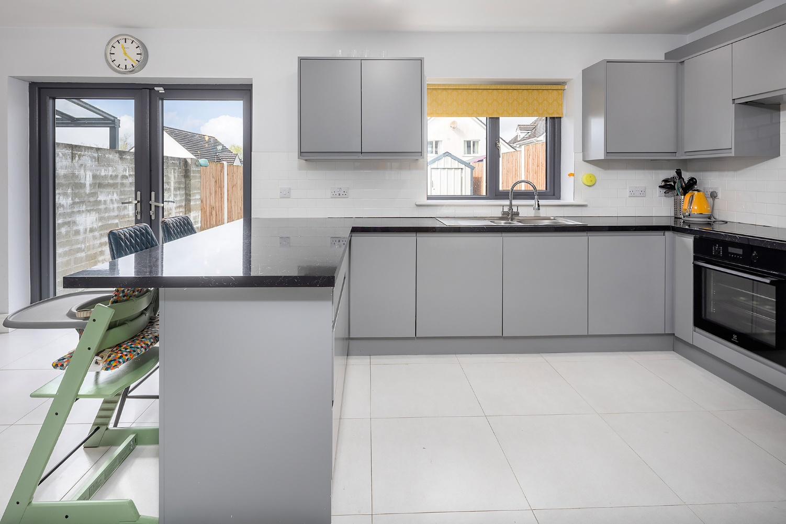

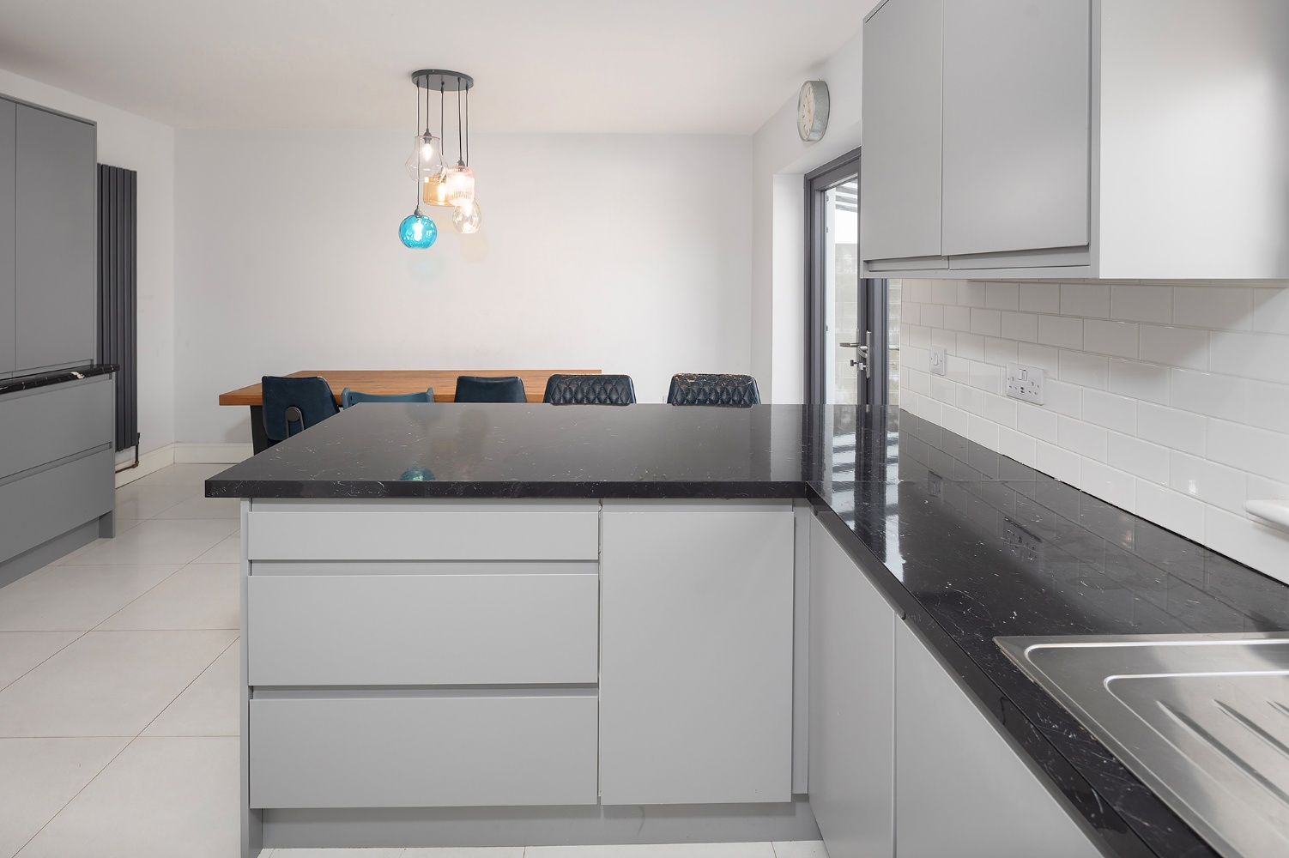
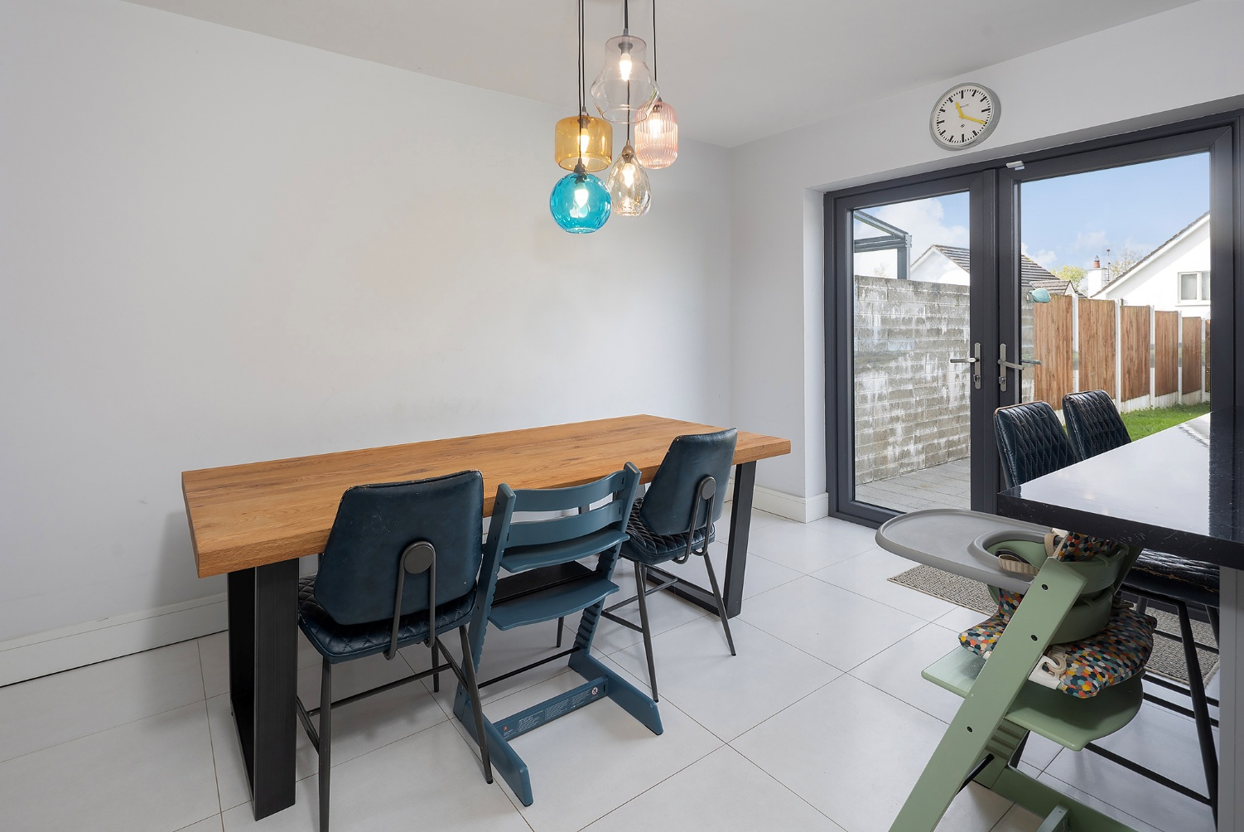

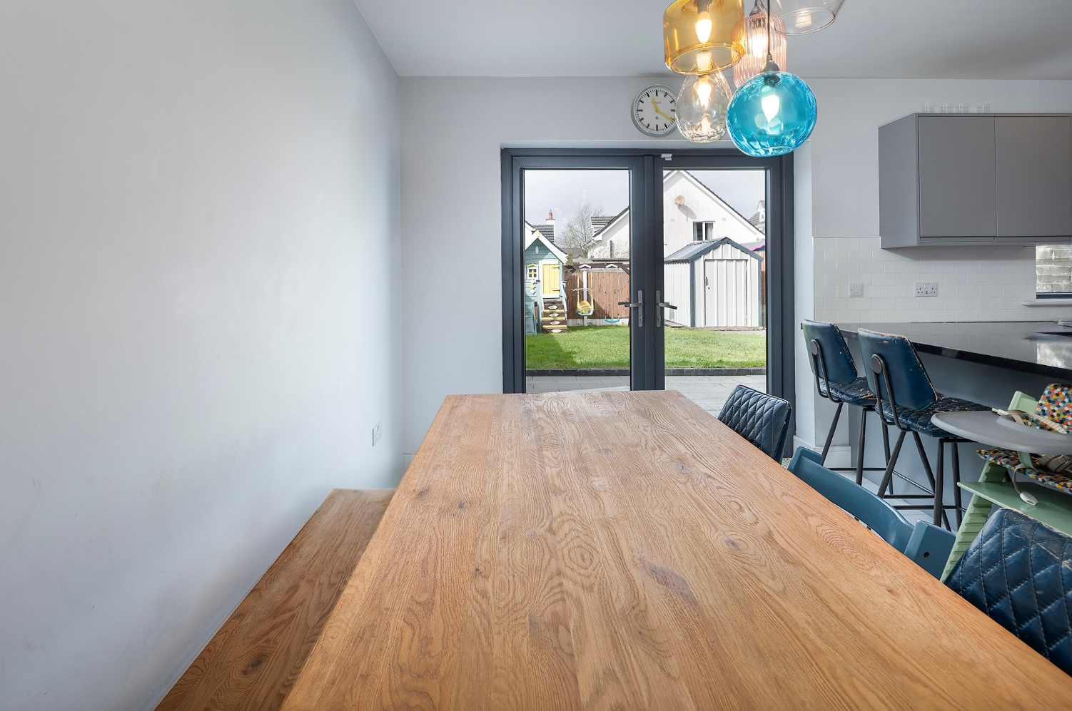

Utility Room: 1.81 x 1.46 ceramic tiled floor, plumbed for washing machine & dryer, floor standing & wall mounted storage.

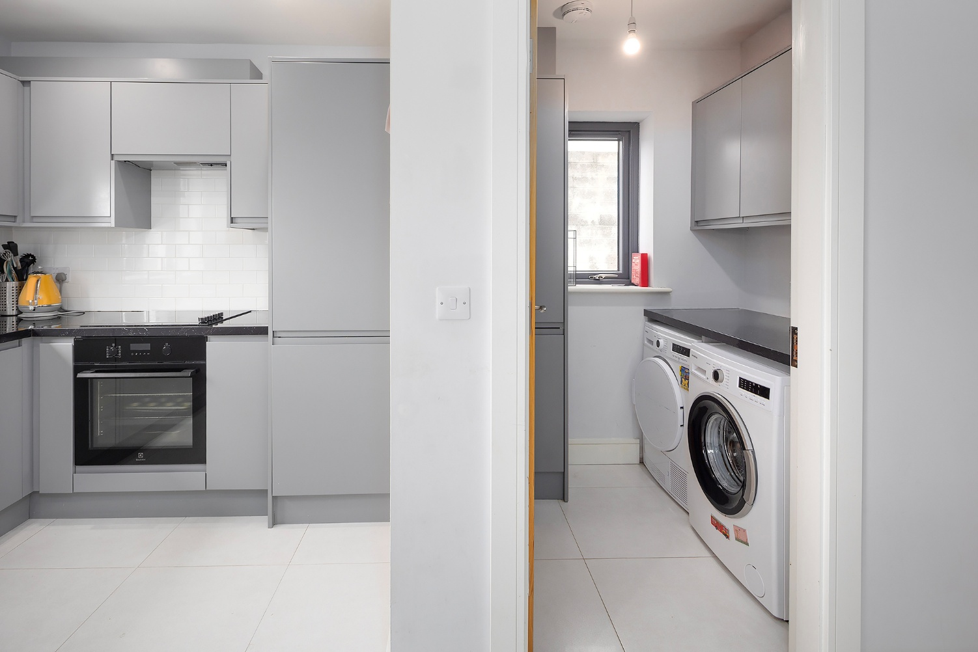

FIRST FLOOR :

Master Bedroom: 4.52 X 3.58 rear aspect, double built-in sliderobes.

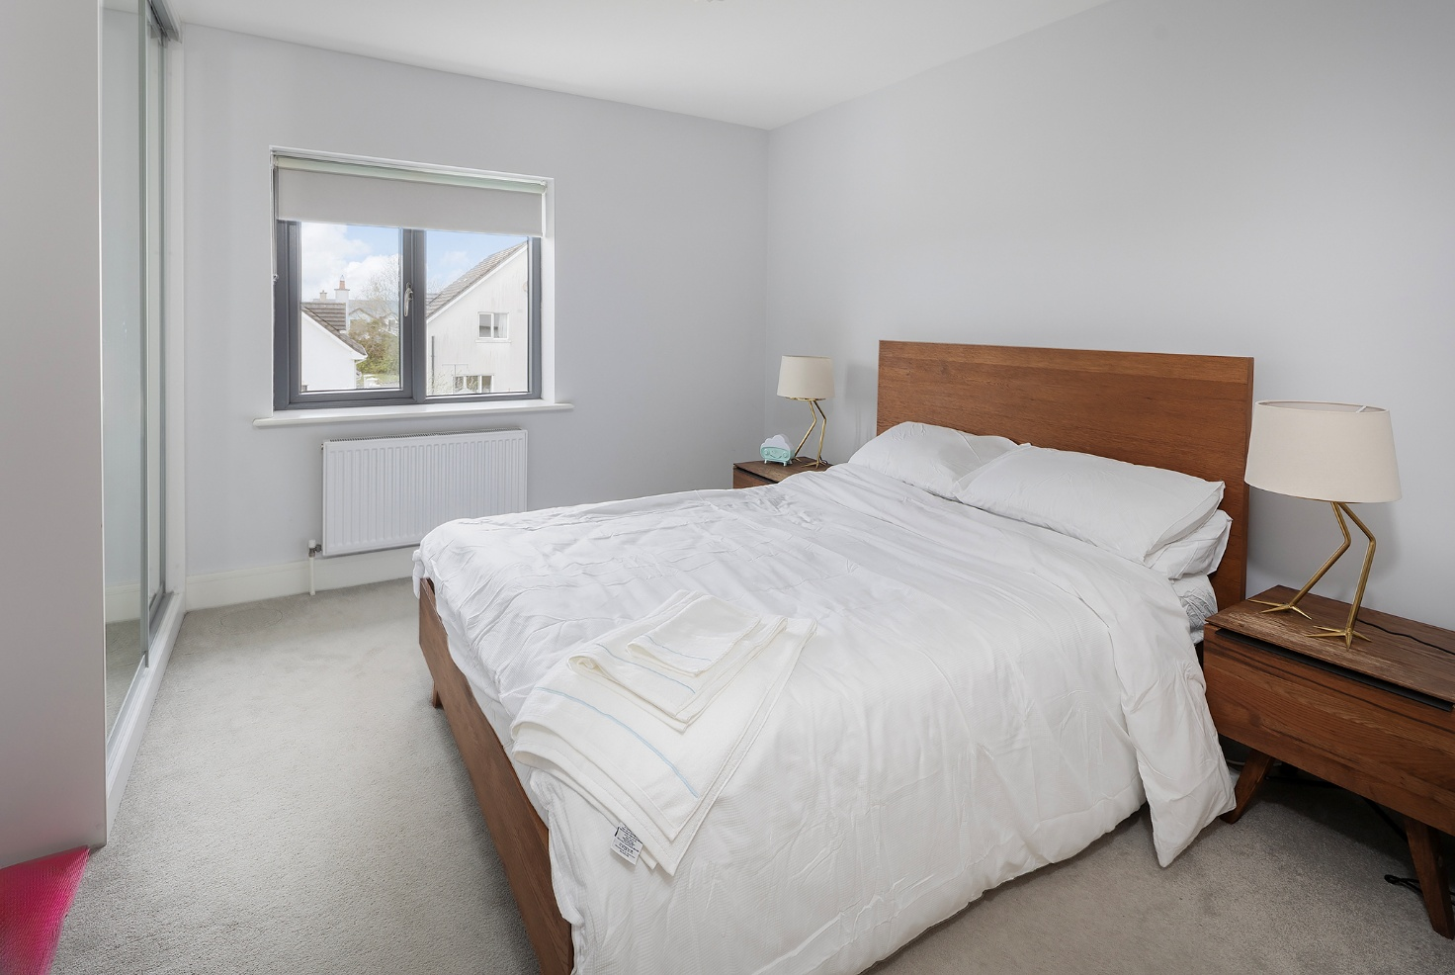

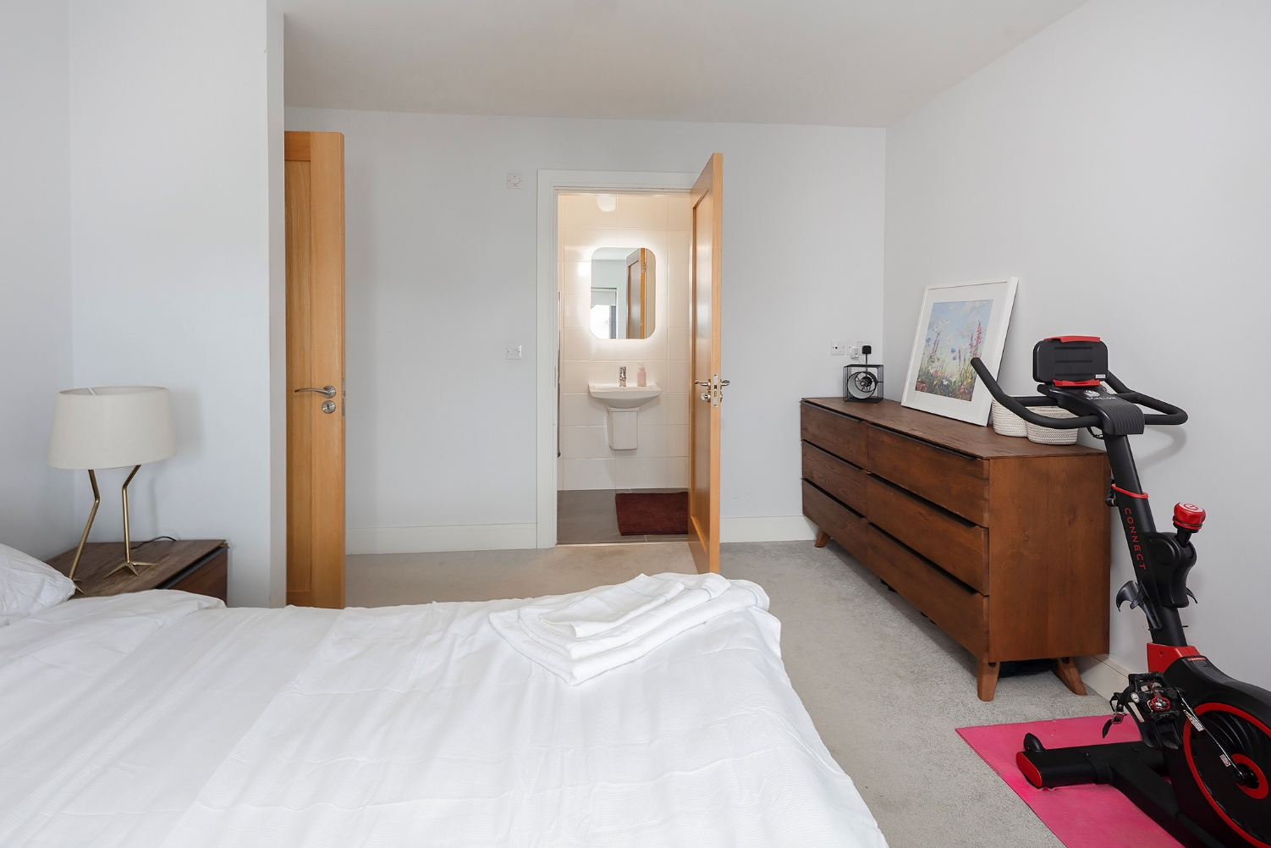

En-suite : 2.72 x 1.11 fully tiled with power shower, w.c. & w.h.b.

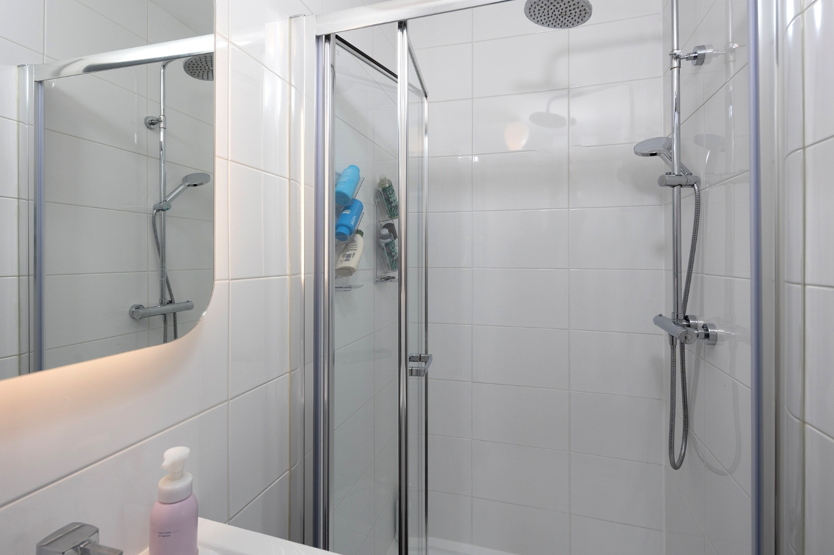

Bedroom 2 : 3.98 x 2.94 front aspect, extensive built-in sliderobes.

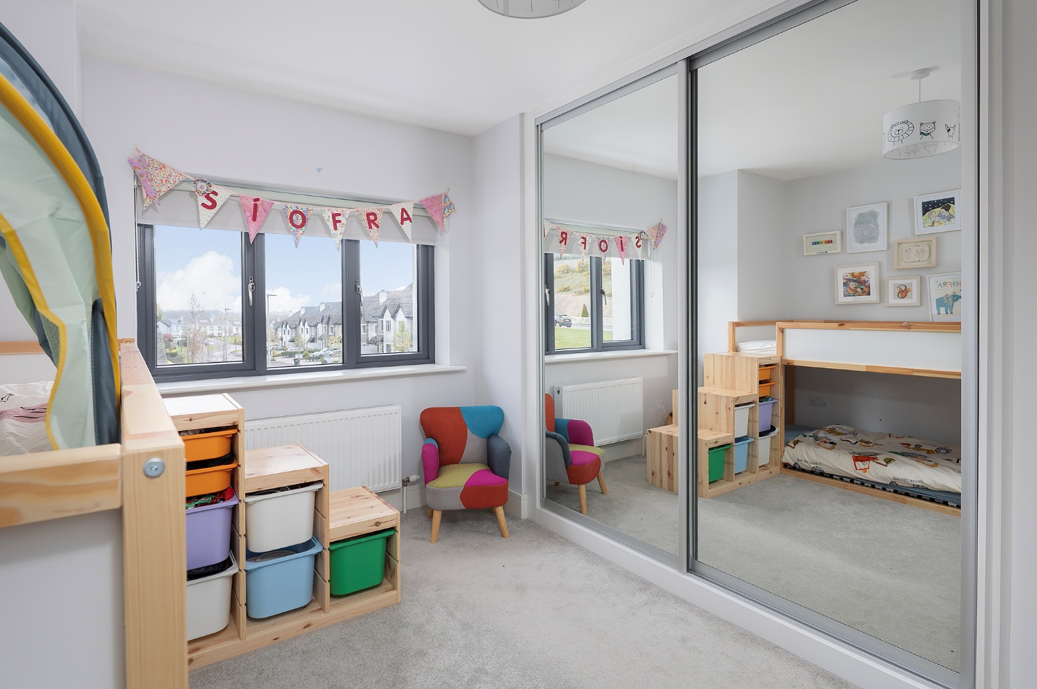

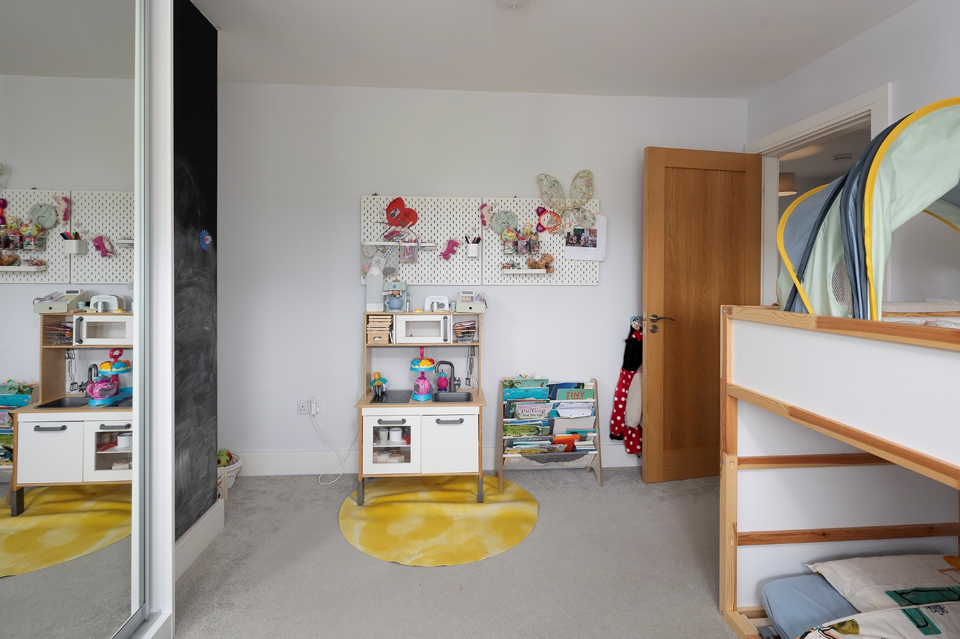

Bedroom 3: 3.34 x 2.46 rear aspect.

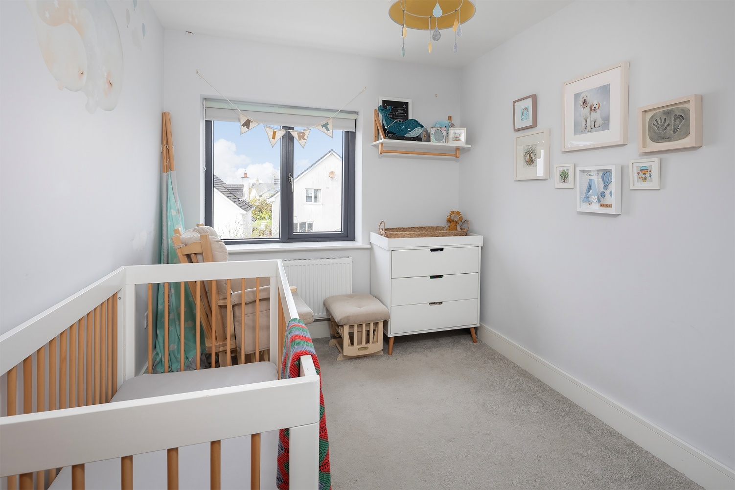

Bathroom: 2.46 x 2.30 fully tiled with bath, power shower, w.c & w.h.b

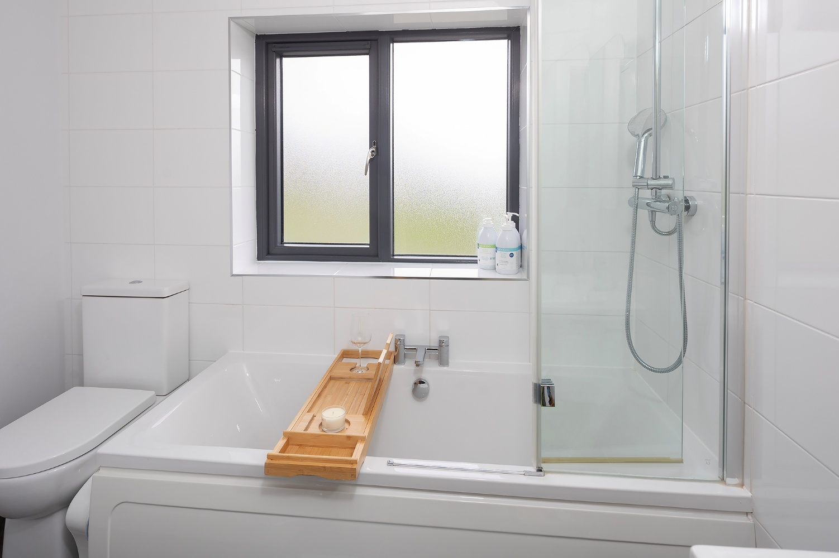

ATTIC: 6.27 X 5.24 – ready for conversion with Stira access, fully floored & wired with 2 velux windows, includes plant room.

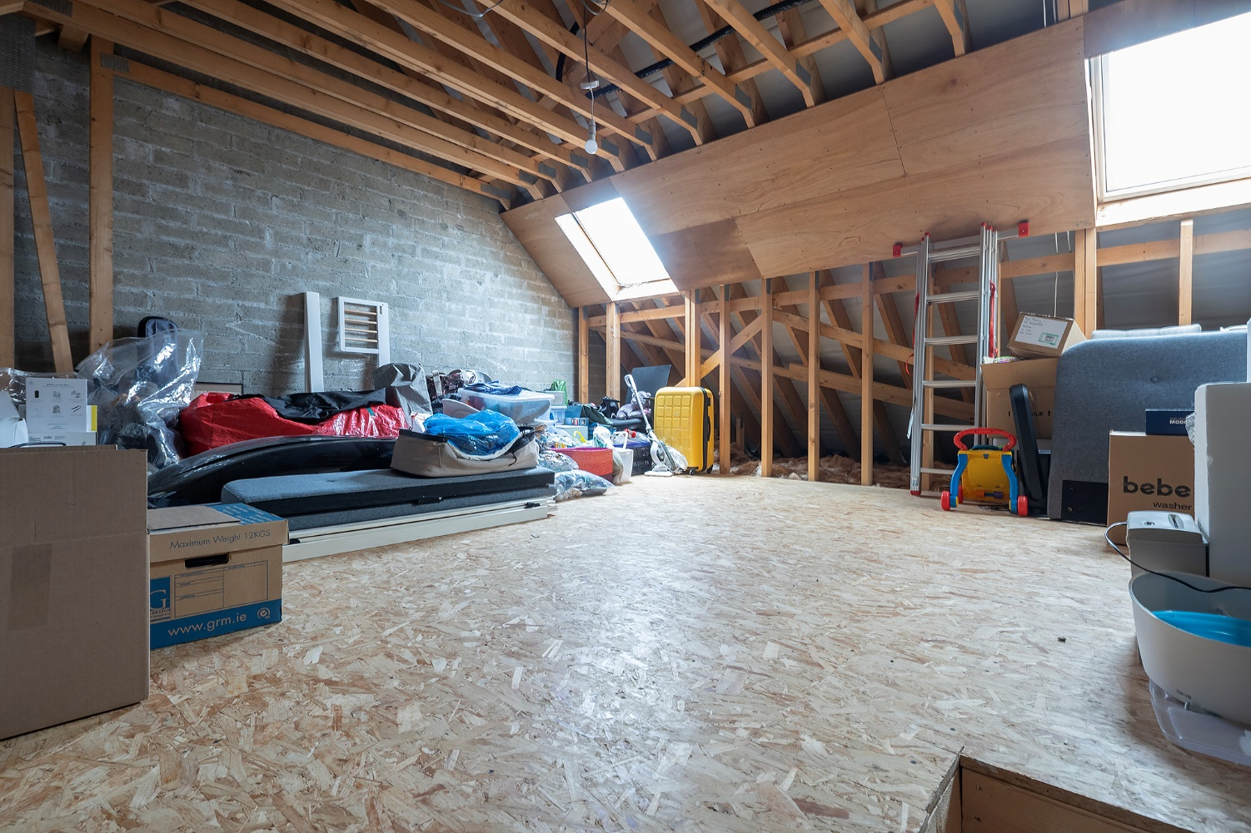

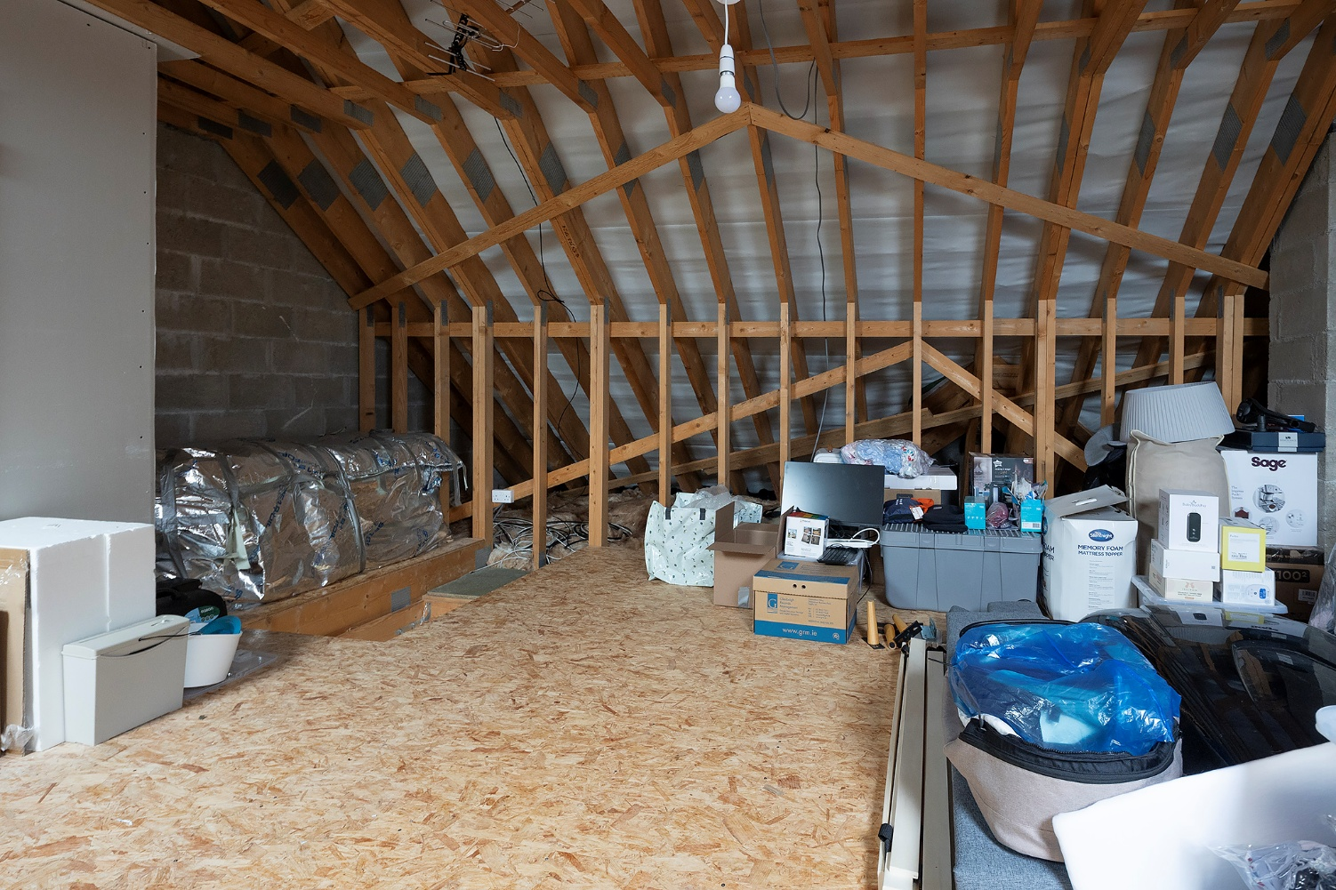

OUTSIDE :

Cobble-lock driveway to the front with parking for 2 vehicles.
Enclosed Westerly facing rear garden with steel garden shed & patio area.

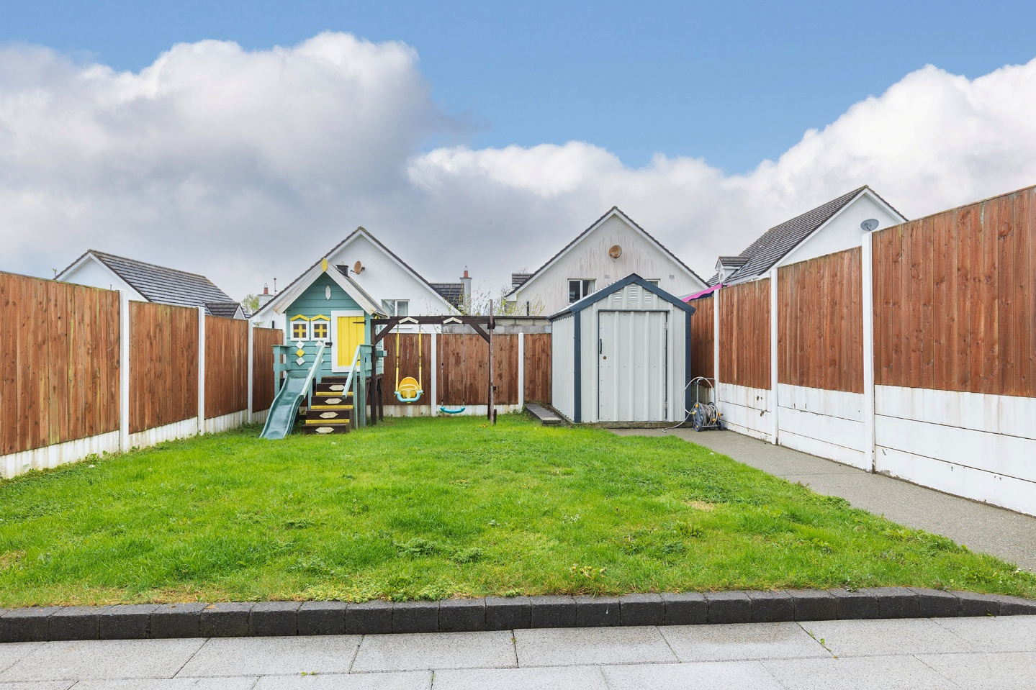

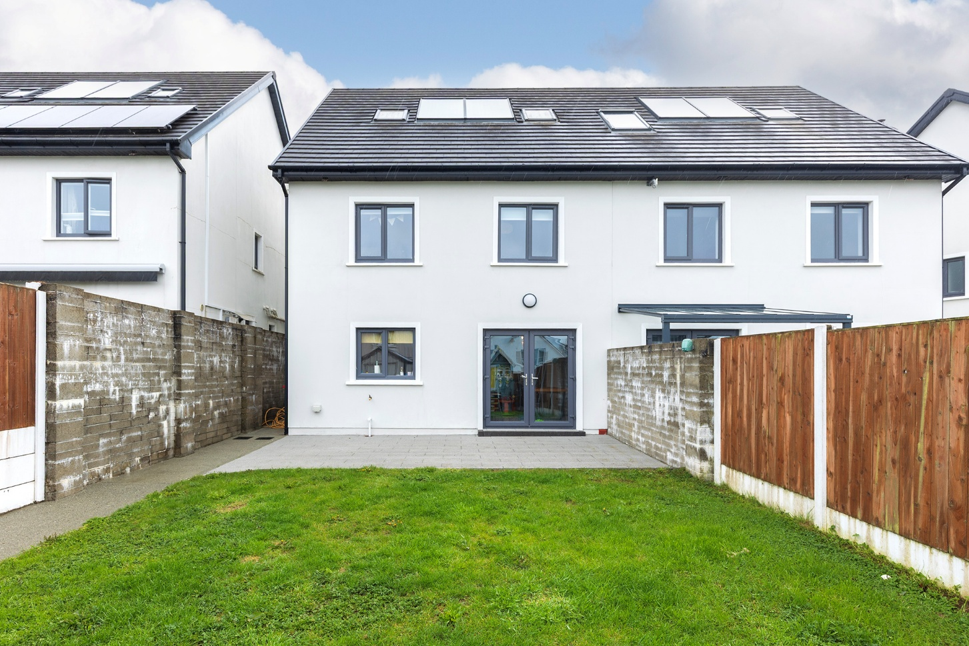

GROUND FLOOR:

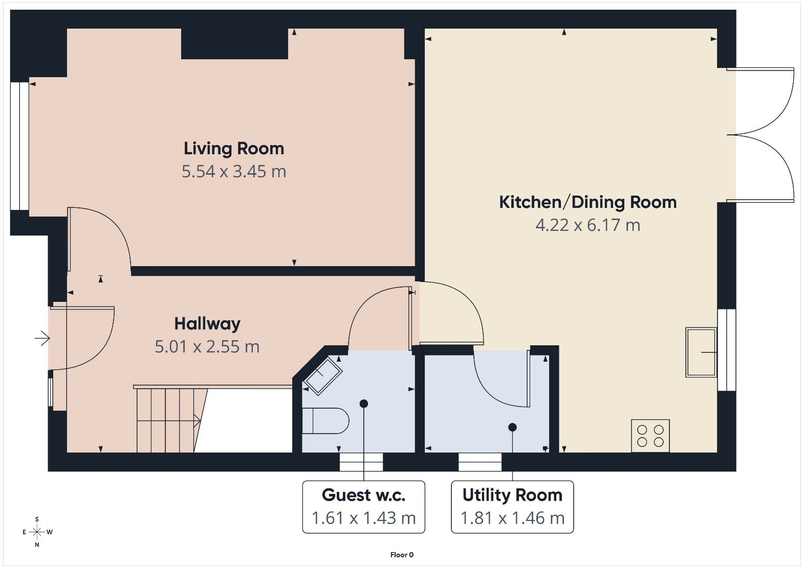
FIRST FLOOR :
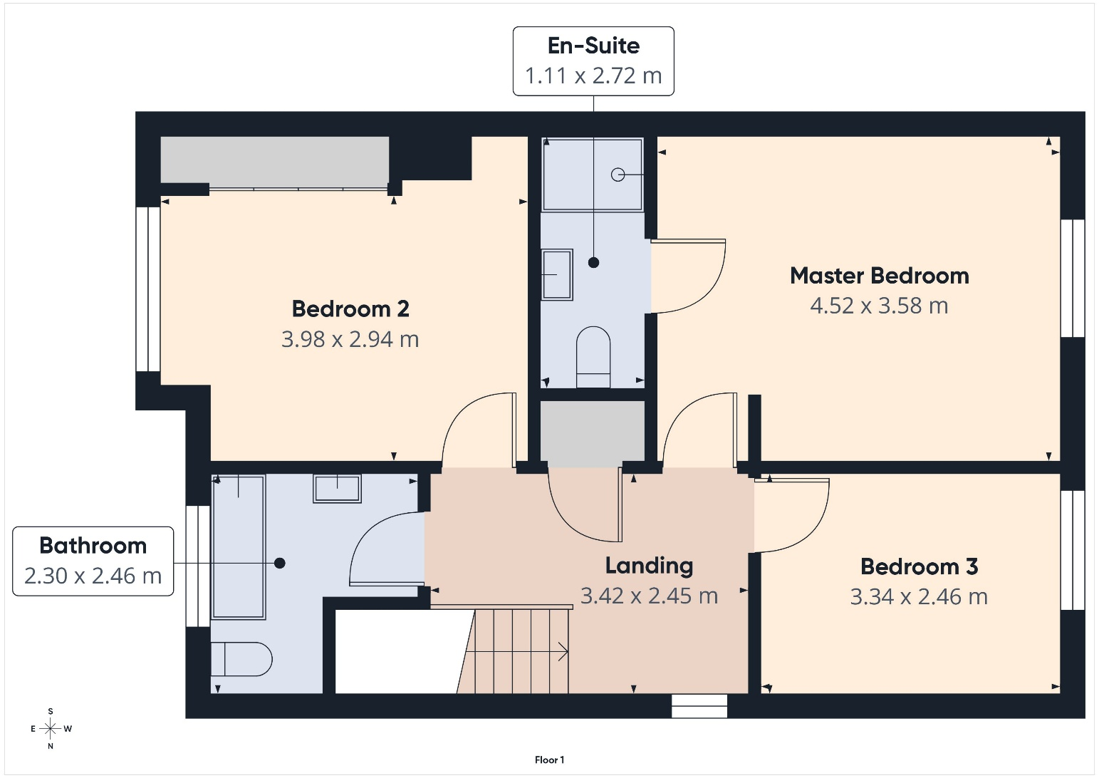

ATTIC :

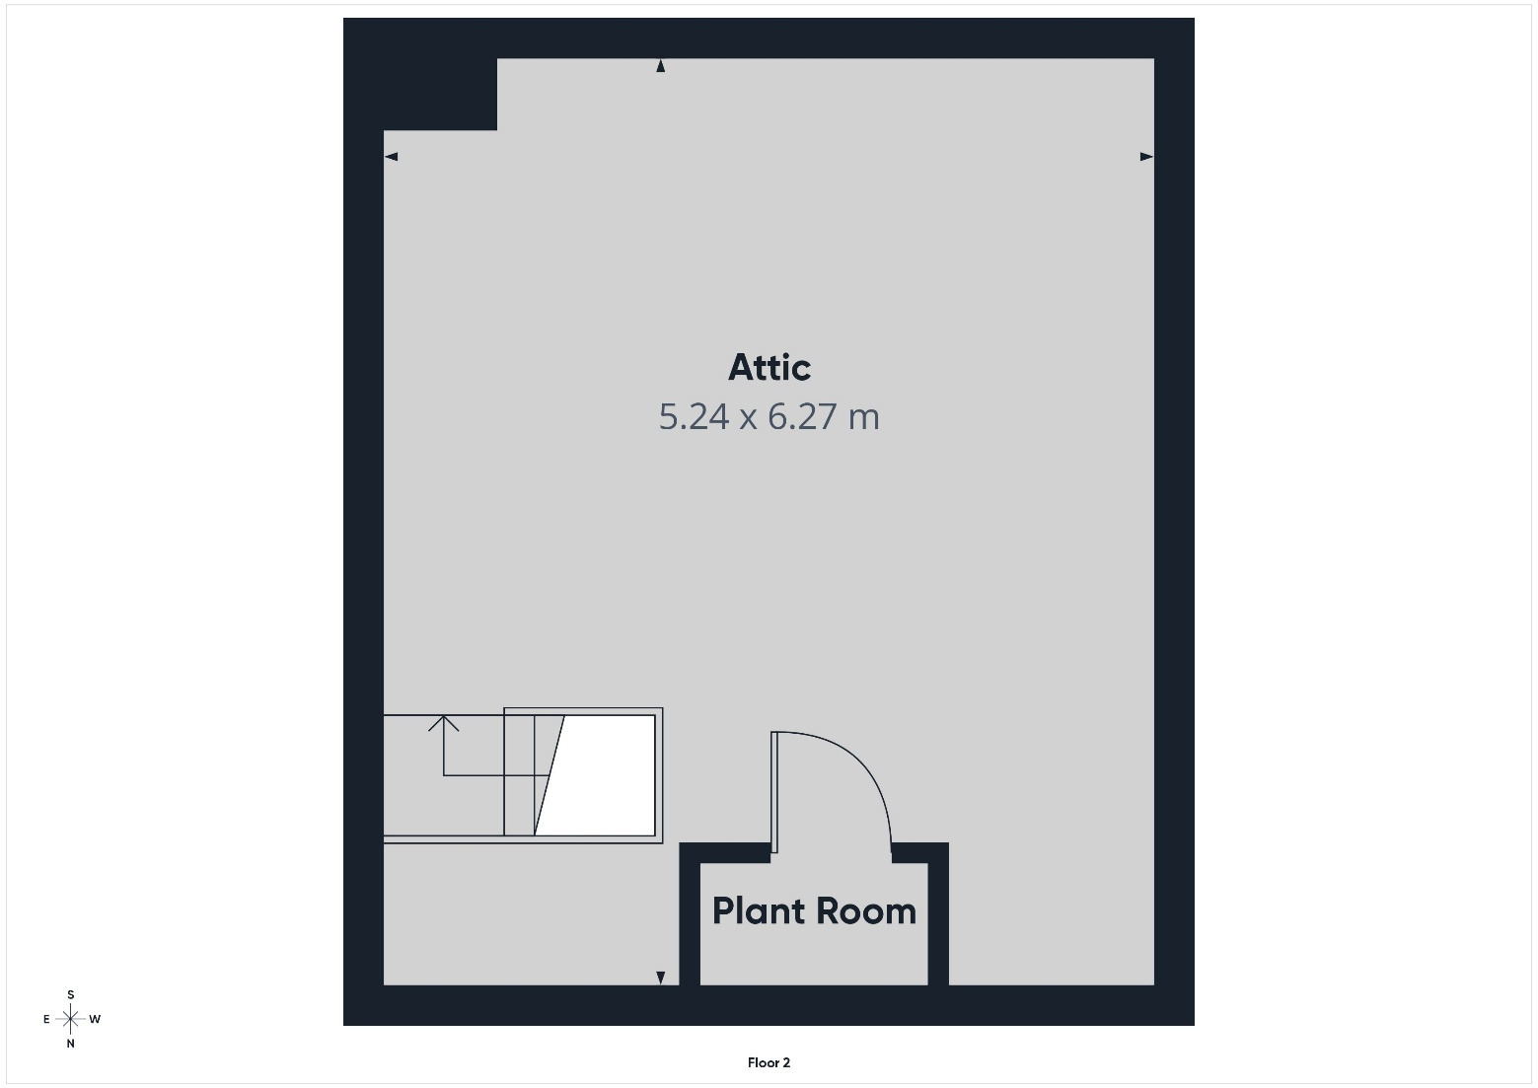

FEATURES:

- Spacious 3 bedroom home extending to c. 118m² (1,270 ft²)
- Stylish & modern home in turn-key condition throughout.
- Guest w.c. on ground floor.
- Master bedroom en-suite.
- Fully floored attic with 2 velux windows (accessed by Stira).
- Cobble-lock drive-way with parking for two vehicles.
- Security Alarm.
- Gas fired central heating with Smart heating control.
- Solar Panels.
- Westerly facing rear garden with patio area & steel garden shed.
- Outside tap & electrical sockets.
- Convenient location, close to Train, Midleton Town Centre & all amenities.
- Situated within walking distance of Midleton’s Main Street & all amenities including shops, bars, supermarket, restaurants, schools, cinema, famous Midleton Farmers Market which takes place every Saturday, along with bus and rail services.
- Easy access to the N25, Jack Lynch Tunnel, Cork City & beyond.

EIRCODE : P25 E7N5

SERVICES: Mains water, drainage & gas.

BER DETAILS: BER- A3 BER No. 112309901

VIEWINGS: Strictly by prior appointment.


39 Main Street, Midleton, Co. Cork t: 021 4631755
2 East Beach, Cobh, Co. Cork t: 021 4811494
42 South Mall, Cork t: 021 4273800
E: info@mccarthymcgrath.com w: www.mccarthymcgrath.com
PSRA Licence No. 001757
_______________________________________________________________________________________________________________________________________________
These particulars are issued by McCarthy & McGrath on the understanding that any negotiations respecting the Property mentioned are conducted through them. Every care is taken in preparing particulars, but the firm do not hold themselves responsible for any inaccuracy in the Particulars and Terms of the Property referred to or for any expense that may be incurred in visiting same should it prove unsuitable, or to have been let, sold or withdrawn. Applicants are advised to make an appointment through us before viewing and are respectfully requested to report their opinion after inspecting. Should the above not be suitable, please let us know your exact requirements. Any reasonable offer will be submitted to the owners for consideration.

